**Practical Assignment**

**Objective: - Image Super-Resolution**

Image Super Resolution refers to the task of enhancing the resolution of an image from low-resolution (LR) to high (HR).

Deep learning techniques have been fairly successful in solving the problem of image and video super-resolution

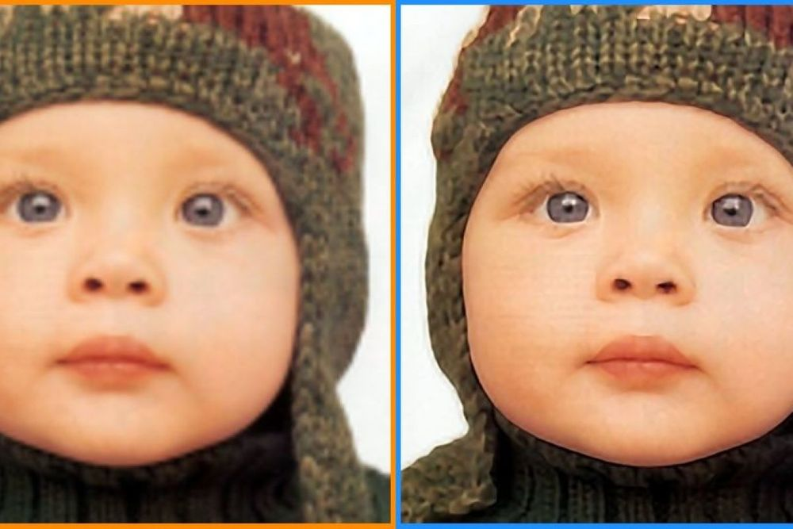

**Dataset Link: -**

Use anyone of your choice.

**Task: -** Create a Web Application using FASTAPI. Use the end user should be able to upload an image and get results with the prediction.

**Deployment: -** Any Free Platform(Try to look out for free options.)

**Assignment Submission: -** Only submit the hosted app link. OR GitHub Link